KEEGAN TIMES: 11-17-17 vkeegan@riverdale.k12.wi.us
Reading | - Please return reading logs every day.  - Next week: Animal in Poems  - Essential Question: What do we love about animals?  - Genre: Poetry  - A rhyming poem:  - Has words that end with the same sounds.  - Tells a poet’s thoughts or feelings.  - Vocabulary Strategy: Multiple-Meaning Words  - Multiple-meaning words are words that are spelled the same but have more than one meaning. You can use context clues to help you understand the correct meaning.  - Vocabulary: behave, flapping, express, feathers, poem, rhythm, rhyme, word choice  - Comprehension strategy: Reread.
Spelling | - Three- Letter Blends scr, spr, str, thr, spl, shr: scratch, scrape, spring, throne, stripe, strange, shred, shrub, splash, split  - Review High-Frequency Words: catch, sting, far, flower, until  - Pretest on Monday, 0-2 wrong will study List B.
MATH  - Riverdale Family Page: REFLEX Math - Great Job earning those GREEN Lights! | - Unit 2 Addition within 200  - Explore 2-Digit Addition  - Review proof drawings and expanded form  - Explore methods of 2-digit addition that involve making a new ten or hundred.  - Solve word problems involving money  - Count Dimes by 10, Nickels by 5, Pennies by 1  - Open Number Line  - Key Vocabulary: ones, tens, hundreds, decade numbers, Quick Tens, expanded form, new groups above, new groups below, show all totals
Educational Websites | - www.sheppardsoftware.com  - www.eduplace.com  - www.spellingcity.com  - www.fun4thebrain.com  - www.eduplace.com  - www.thinkcentral.com  - www.abcya.com
Science  Social Studies | - Riverdale home page, staff, resources:  - Tumble Books: username: remschool  - password: books  - PebbleGo- Username: res Pass: school  - Google: Food Pyramid game “Blast off”  - Essential Question: What do we love about animals?
- Thank you to our Math Coach, Mrs. Schaefer! We loved your Open Number Line lesson!  - Thanksgiving Break:  November 24-25, No School | - Monday, Day 1: Guidance and Music  - Tuesday, Day 2: PE  - Wednesday, Day 3: Art  - Thursday, Happy Thanksgiving, No School  - Friday, No School
Character  Education:  Warm Winter clothes for recess please! | - The Riverdale Way: RESPECTFUL  - Do you treat others the way you would like to be treated?  - Do we strive for a happy and healthy recess?  - We enjoyed learning about Dayana!!!  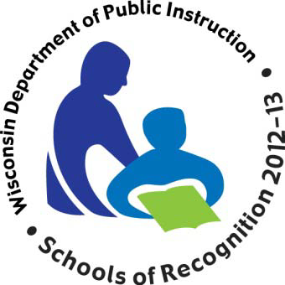  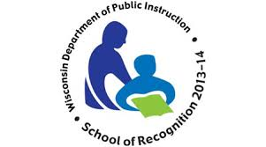  - Next Star of the Week: Ashley (11/27-12/1)!

